Title Here, Centered, Bold, Title Case Heading:
One to Two Lines

Author Names here, First M. Last¹, Jane M. Roe², and John Doe³
¹ Department of Communication, ACR University
² Communication Research Center, University of ACR
³ Department of Media and Communication, University of ACR

Author Note
First M. Last https://orcid.org/authors’_ocr_id_number_if_they_have_one
Jane M. Roe https://orcid.org/authors’_ocr_id_number_if_they_have_one
John Doe https://orcid.org/authors’_ocr_id_number_if_they_have_one
Changes of affiliation, for example, First M. Last is now at KSJCS University.
Disclosures and acknowledgement, for example, This article is based on the dissertation completed by Jane M. Roe (2021), and/or This work was supported by Funding Sources (funding number).
Correspondence concerning this article should be addressed to John Do, Department of Media and Communication, University of ACR, 124, Sejong-daero, Jung-gu, Seoul, 04520, Republic of Korea. Email: acr@comm.or.kr
PLEASE SEPARATE THIS TITLE PAGE HERE FROM THE MAIN TEXT BELOW BEFORE SUBMITTING
Abstract
The abstract should be ONE paragraph (no indent) of between 150 and 200 words. It is recommended that the abstract include the context/purpose of the study, the basic procedures/methods used, the most important results, and principal conclusions. Please be aware that the abstract can draw readers into or drive them away from your research.
Keywords: words, phrases, or acronyms, up to six keywords

Title Here, Centered, Bold, Title Case Heading:
One to Two Lines
The body of the paper should be left-aligned and double-spaced. Please indent about 1.5 cm the first line of every paragraph. The title above has Level 1 heading style. APA style provides for up to five heading levels, shown below. Note that the word Introduction should not be used as an initial heading, as it is assumed that your paper begins with an introduction.
Level 2 Heading, Flush Left, Bold, Title Case Heading
Text begins as a new paragraph.
Level 3 Heading, Flush Left, Bold Italic, Title Case Heading
Text begins as a new paragraph.
Level 4 Heading, Indented, Bold, Title Case Heading, Ending With a Period. Text begins on the same line and continues as a regular paragraph.
Level 5 Heading, Indented, Bold Italic, Title Case Heading, Ending With a Period. Text begins on the same line and continues as a regular paragraph.
In-Text Citation Styles
In an in-text citation, provide the surname(s) of the author(s) and the year of publication. In parenthetical citations, the author name and publication date appear in parentheses; in narrative citations, the author appears in text, and the date appears in parentheses immediately after the author name.
Parenthetical citation Narrative citation
One author (McCombs, 2005) McCombs (2005)
Two authors (McCombs & Shaw, 1972) McCombs and Shaw (1972)
Three or more (Chung et al., 2020). Chung et al. (2020)
Method
Participants
Measures
Measurement One
Results
Discussion

References
References begin on a new page. All citations mentioned in the text, tables, or figures must be listed alphabetically in the following standard form. Provide surnames for up to 20 authors; for 21 or more authors, insert an ellipsis between the 19th and the final author’s name.
Journal article
Chung, S., Carpenter, C. J., Shin, H., & Lee, W. (2020). Three models for persuasive effects of source expertise: The heuristic cue model, the evidence model, and the moderator model. Asian Communication Research, 17(1), 40–75. http://doi.org/10.20879/acr.2020.17.1.40
McCombs, M. E., & Shaw, D. L. (1972). The agenda-setting function of mass media. Public Opinion Quarterly, 36(2), 176–187. https://doi.org/10.1086/267990
Journal article, advance online
Author, A., & Author, B. (2021). Title of article. Title of Journal. Advance online publication. https://doi.org/XXXX
Book
Jin, D. Y. (Ed.). (2020). Transmedia storytelling in East Asia. Routledge.
Perse, E. M., & Lambe, J. L. (2017). Media effects and society (2nd ed.). Routledge.
Chapter in an edited book
Kim, Y. C. (2017). Urban communication and community studies: Korean communication scholar's perspectives. In D. Y. Jin & N. Kwak (Eds.), Communication, digital media, and popular culture in Korea (pp. 321-340). Lexington Books.
Book in another language
Hong, S.-K. (2020). BTS gil wieseo [BTS on the road]. Across.
Kim, Y. C. (2020). Nyumidieowa ijumin [New media and immigrants]. Jipmoondang.
Book in translation
Ong, W. J. (2018). Orality and literacy (M. Lim, Trans.). Moonye (original work published 1982).
Goffman, E. (2013). Interaction rituals (S. Jin, Trans.). Acanet (original work published 1967).
Conference paper
Chung, S., & Fink, E. L. (2018, May 24–28). Mathematical models of the effect of message discrepancy on belief change: Previous models and a modified psychological discounting model [Paper presentation]. International Communication Association 68th Annual Meeting, Prague, Czech Republic.
Online news article
Jacobs, A. (2021, February 4). A parallel pandemic hits health care workers: Trauma and exhaustion. New York Times. https://www.nytimes.com/2021/02/04/health/health-care-workers-burned-out-quitting.html
Report by a government agency or other organization
Name of Group. (2020). Title of report. Publisher information and/or URL
Author, A., & Author, B. (2021). Title of report. Publisher information and/or URL
Dissertation and Thesis
Author, A. A. (2019). Title of thesis [Unpublished master’s thesis]. Name of Institution.
Author, B. B. (2020). Title of dissertation/thesis [Doctoral dissertation/Master’s thesis, Name of Institution]. Database or Archive Name. https://xxxx

Table 1
The Title of Table, Italic, Title Case Heading
Year | Women |  | Men
 | Mean | SD | Mean | SD
2012 | 34 | 6.23 | 32 | 7.54
2013 | 36 | 7.21 | 32 | 7.60
2014 | 37 | 7.89 | 41 | 6.57
Note. Include a table number and table title for each table, and start a new page for each table.

Figure 1
The Title of Figure, Italic, Title Case Heading
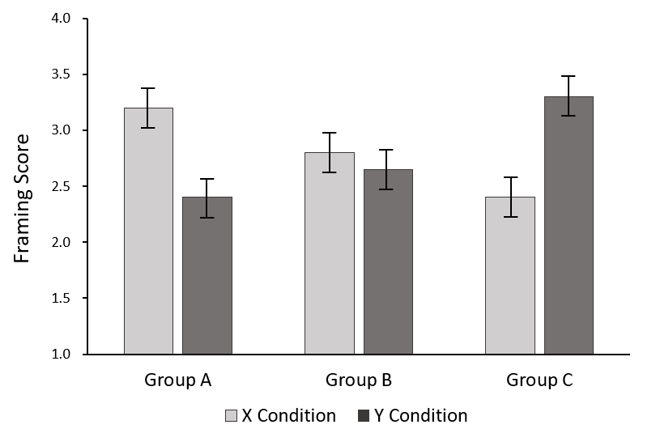
Note. Framing scores of A, B, and C groups are presented for X and Y conditions. Error bars show standard errors.

Figure 2
Structural Equation Model Predicting C
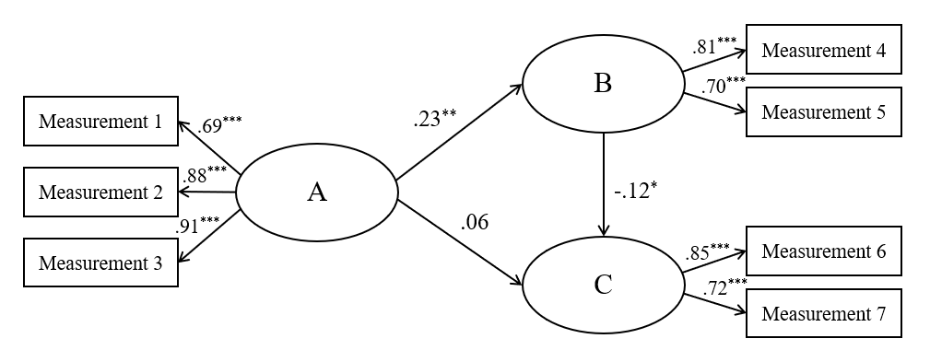
Note. Standardized path coefficients are presented.
* p < .05, ** p < .01, *** p < .001.

Appendix
If the paper has multiple appendices, label each one with a capital letter (e.g., Appendix A, Appendix B) in the order in which it is mentioned in the text.

